PROJECT -1

**PROBLEM STATEMENT:**

**Dataset Description:**

ID,Case Number,Date,Block,IUCR,PrimaryType,Description,Location

Description,Arrest,Domestic,Beat,District,Ward,Community Area,FBICode,X Coordinate,Y Coordinate,Year,Updated On,Latitude,Longitude,Location

**Problem**

1. Write a mapreduce and pig program to calculate the number of cases investigated under each FBI code

2. Write a mapreduce and pig program to calculate the number of cases investigated under FBI code 32.

3. Write a mapreduce and pig program to calculate the number of arrests in theft district wise.

4. Write a mapreduce and pig program to calculate the number of arrests done between October 2014 and October 2015.

**Q1-Write a mapreduce and pig program to calculate the number of cases investigated under each FBI code.**

**SOLUTION:**

**1. MAP REDUCE:**

**PROGRAM:**

DRIVER CLASS

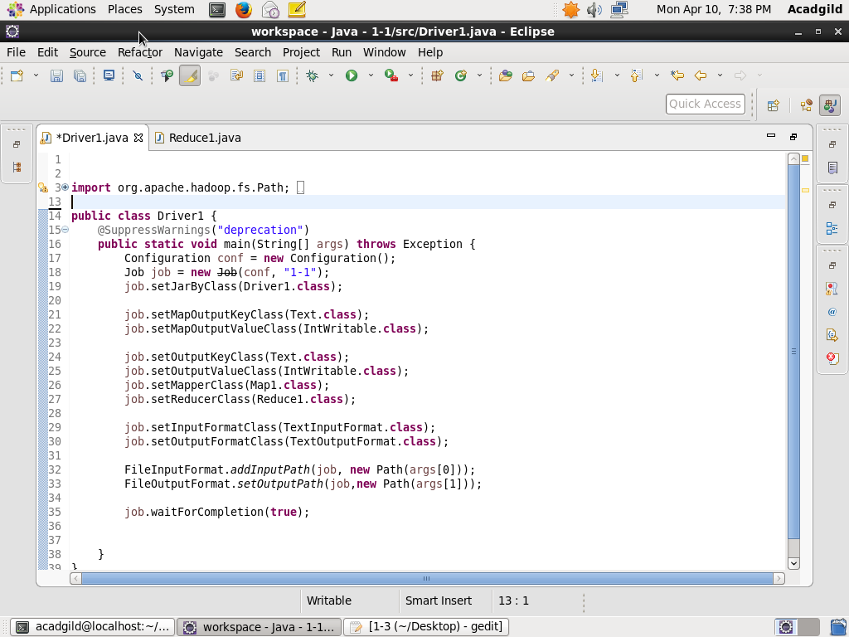

MAPPER CLASS

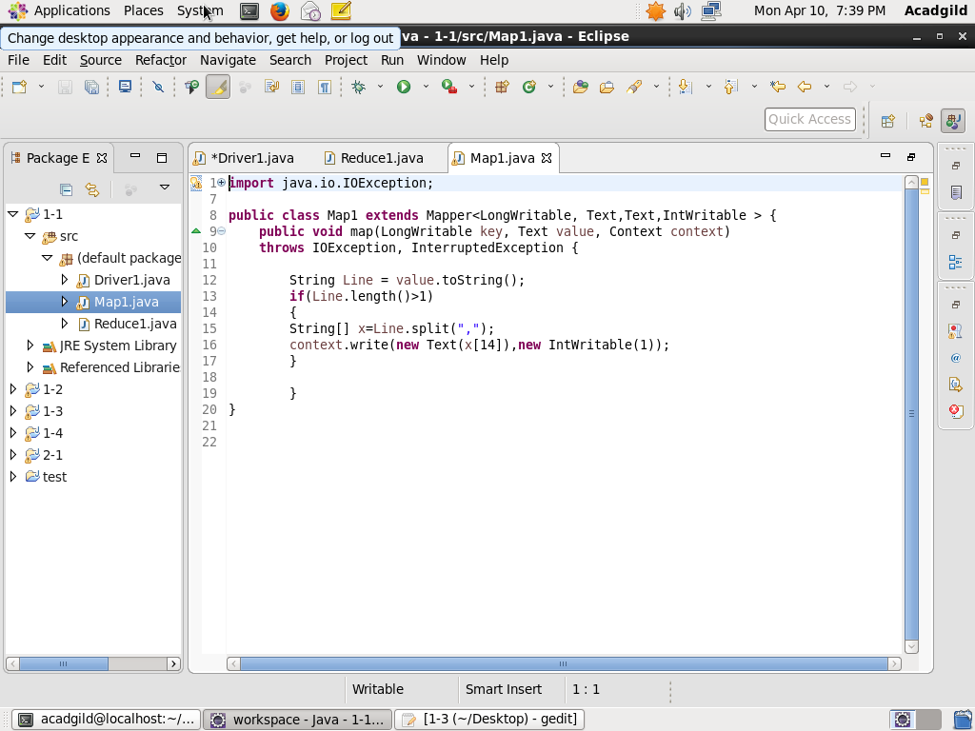

REDUCER CLASS

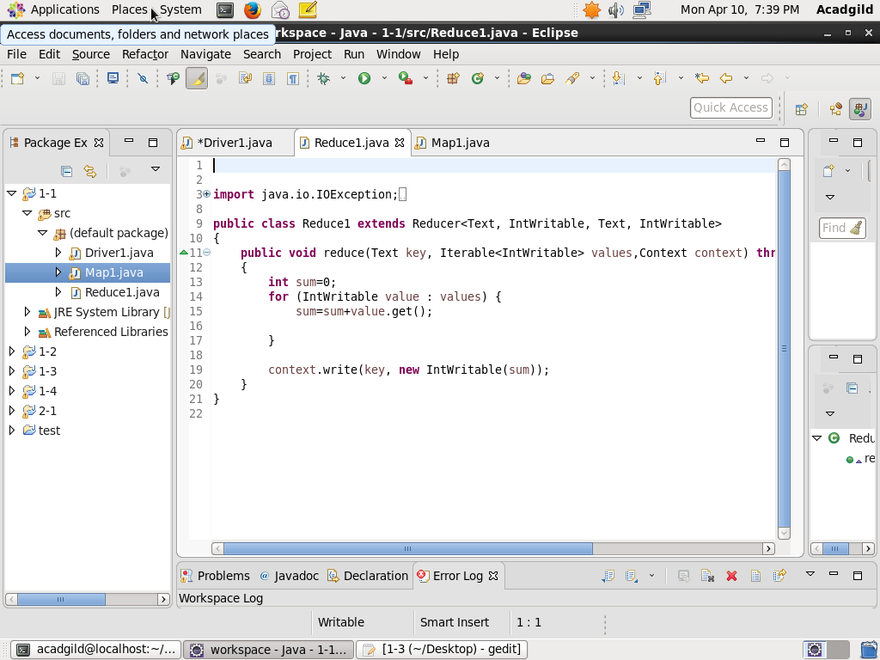

**EXECUTION COMMAND:**

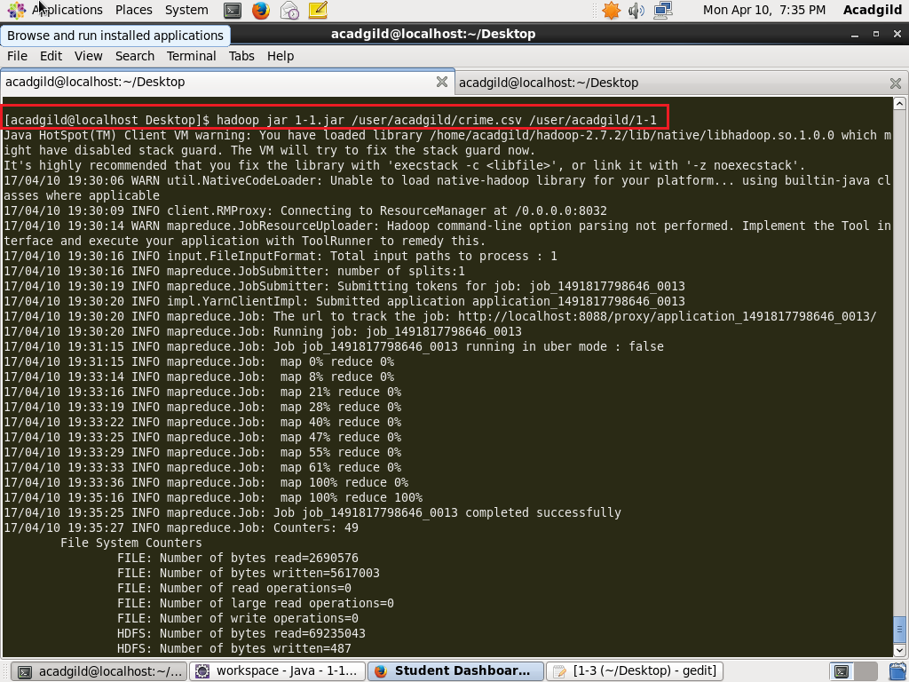

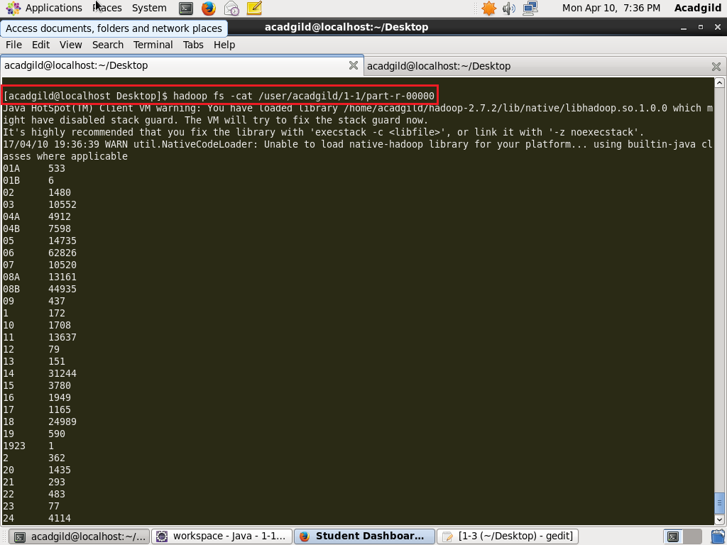

**OUTPUT:**

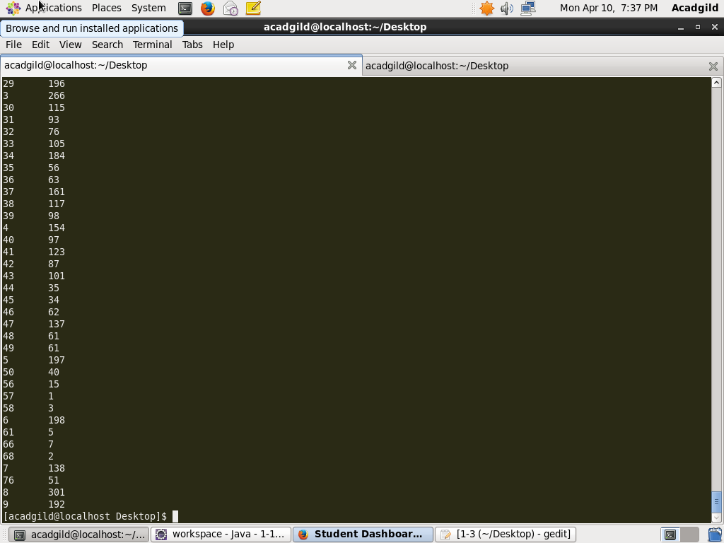

**2. PIG:**

**PROGRAM:**

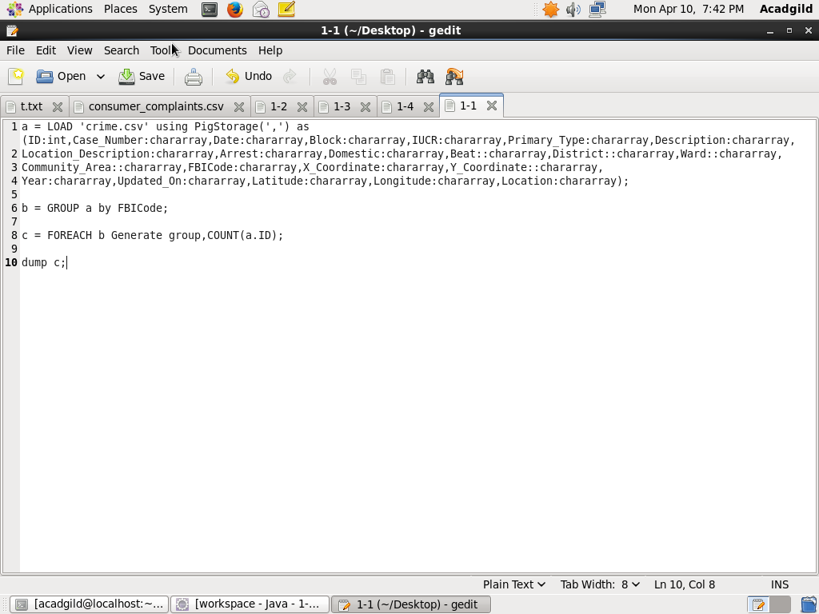

**EXECUTION COMMAND:**

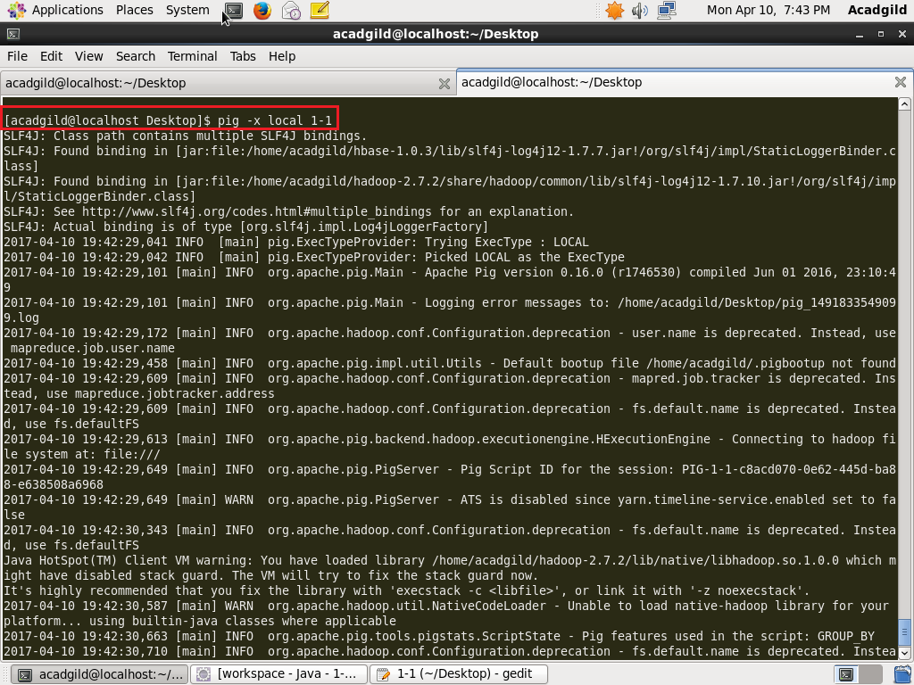

**OUTPUT:**

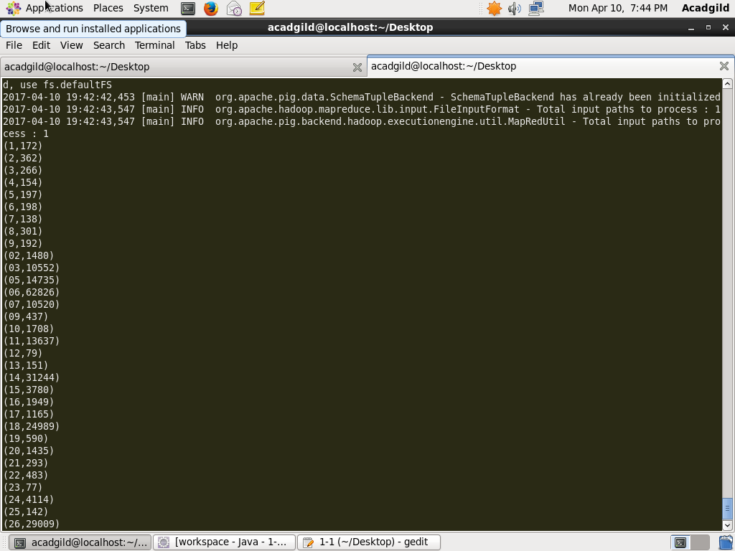

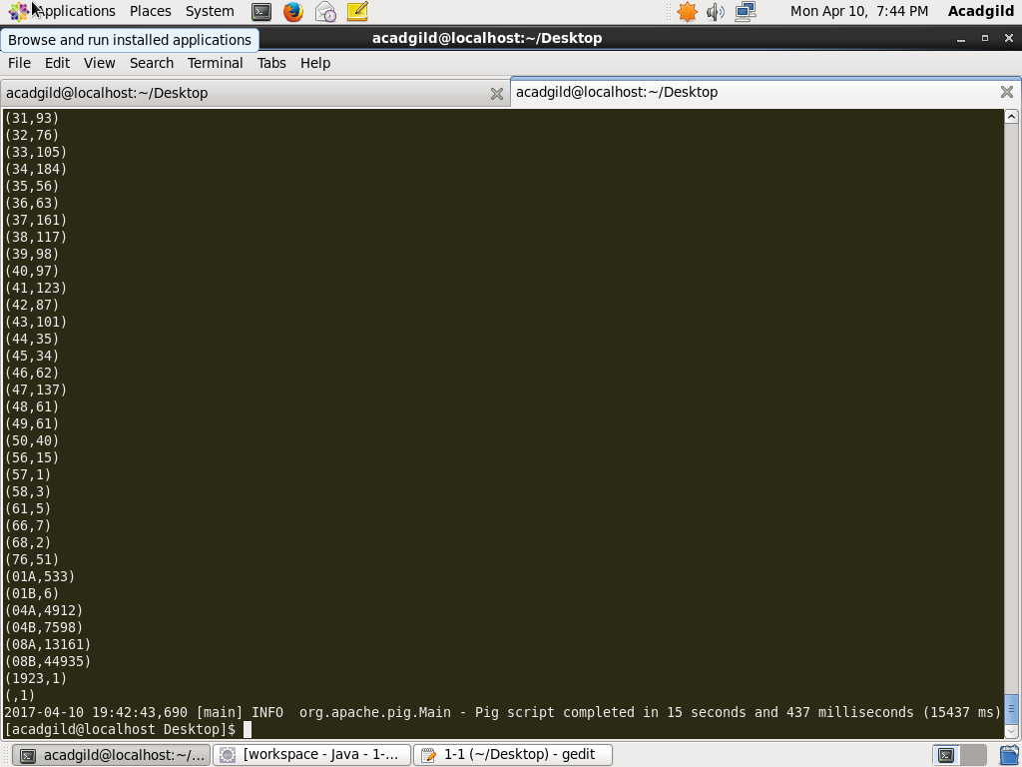

**Q2-Write a mapreduce and pig program to calculate the number of cases investigated under FBI code 32.**

**SOLUTION:**

**1. MAP REDUCE:**

**PROGRAM:**

DRIVER CLASS

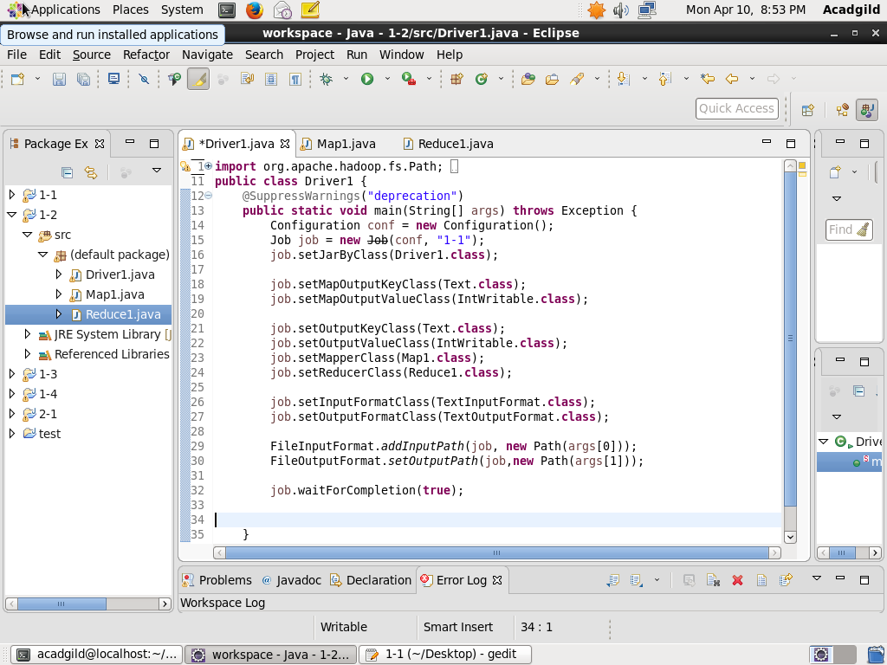

MAPPER CLASS

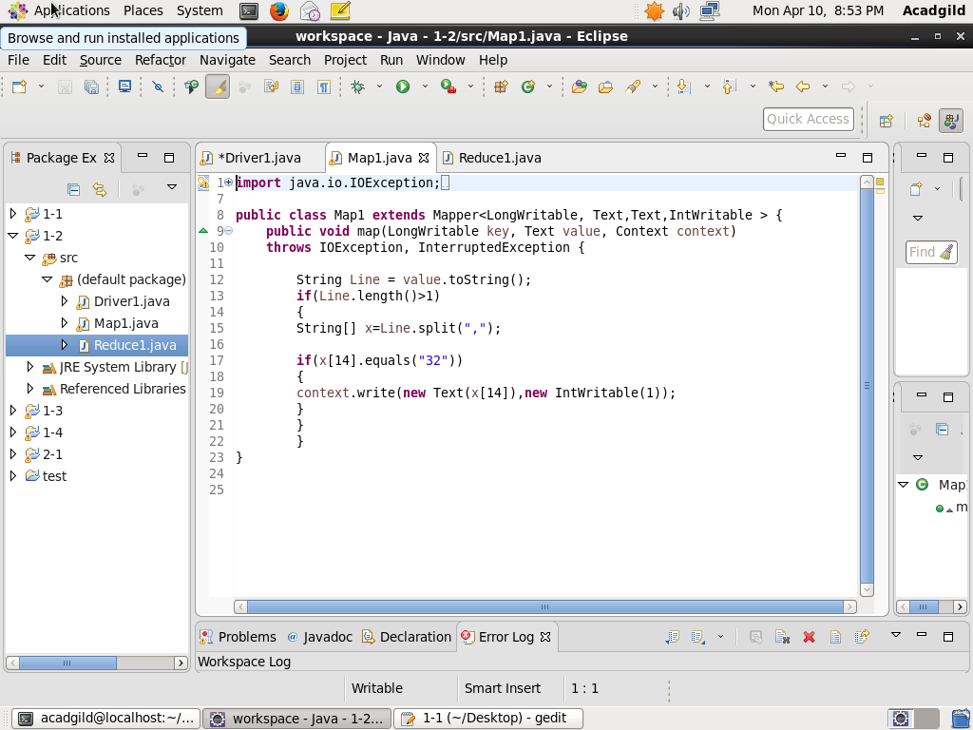

REDUCER CLASS

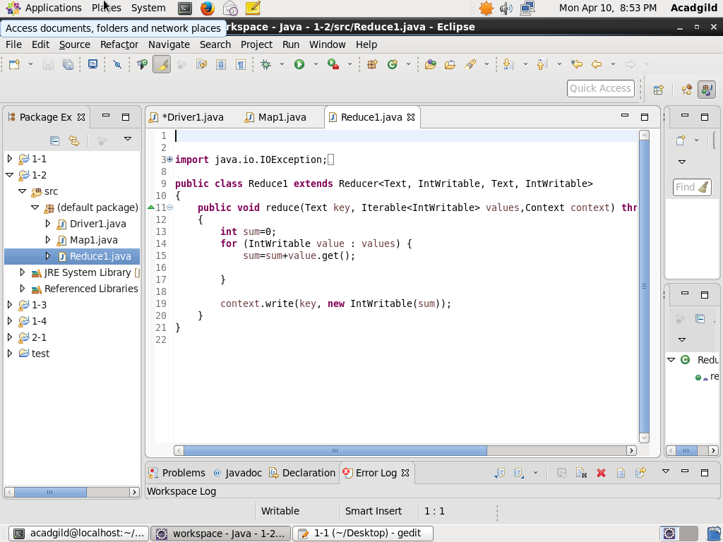

**EXECUTION COMMAND:**

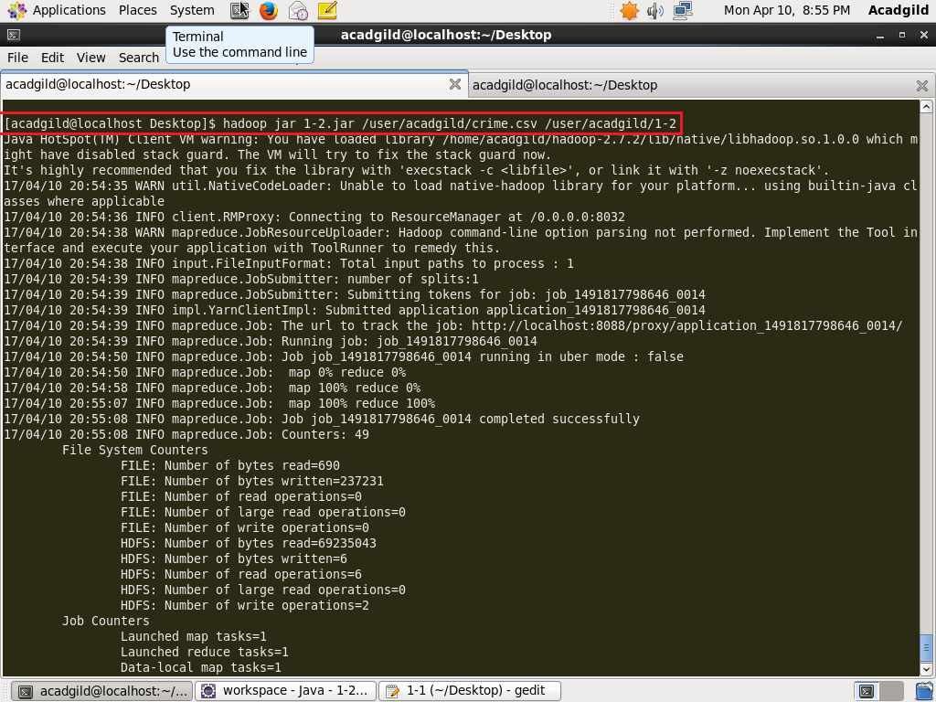

**OUTPUT:**

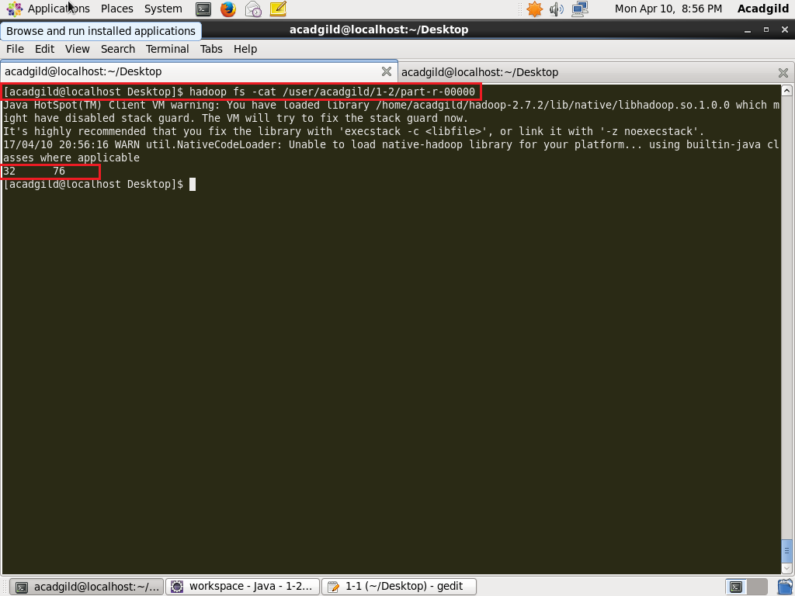

**2. PIG:**

**PROGRAM:**

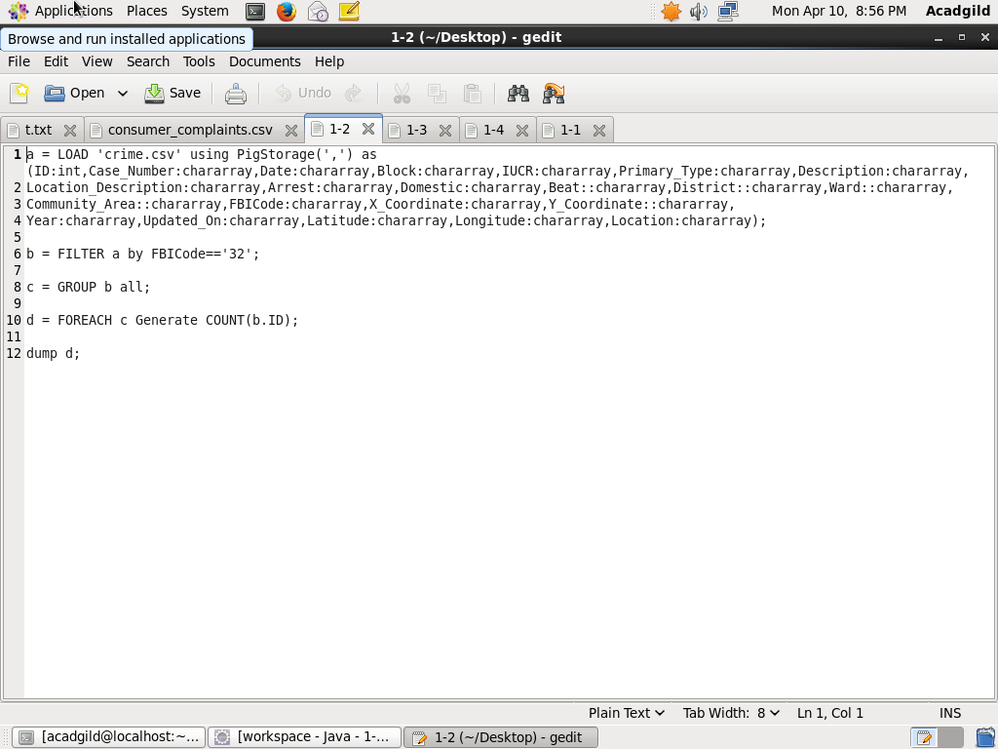

**EXECUTION COMMAND:**

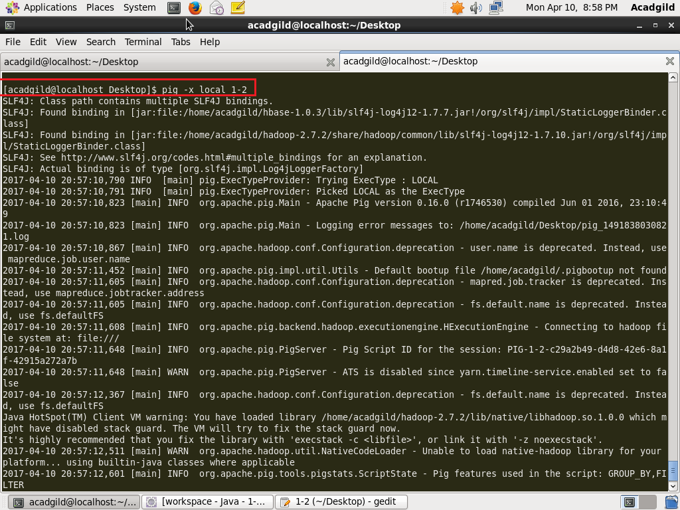

**OUTPUT:**

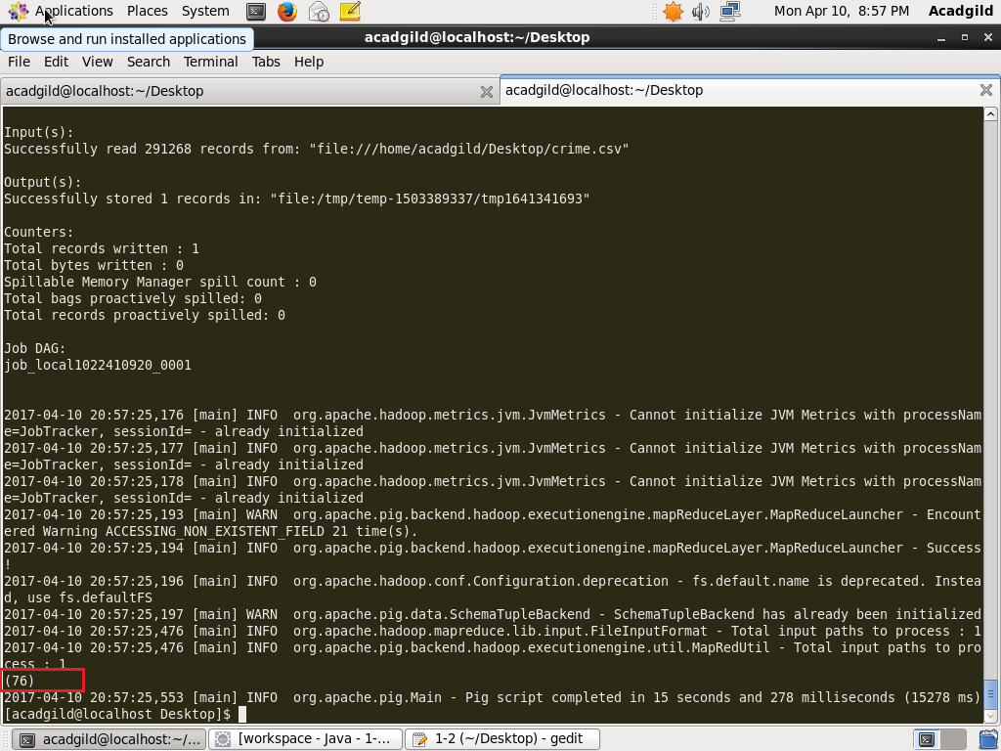

**Q3-Write a mapreduce and pig program to calculate the number of arrests in theft district wise.**

**SOLUTION:**

**1. MAP REDUCE:**

**PROGRAM:**

DRIVER CLASS

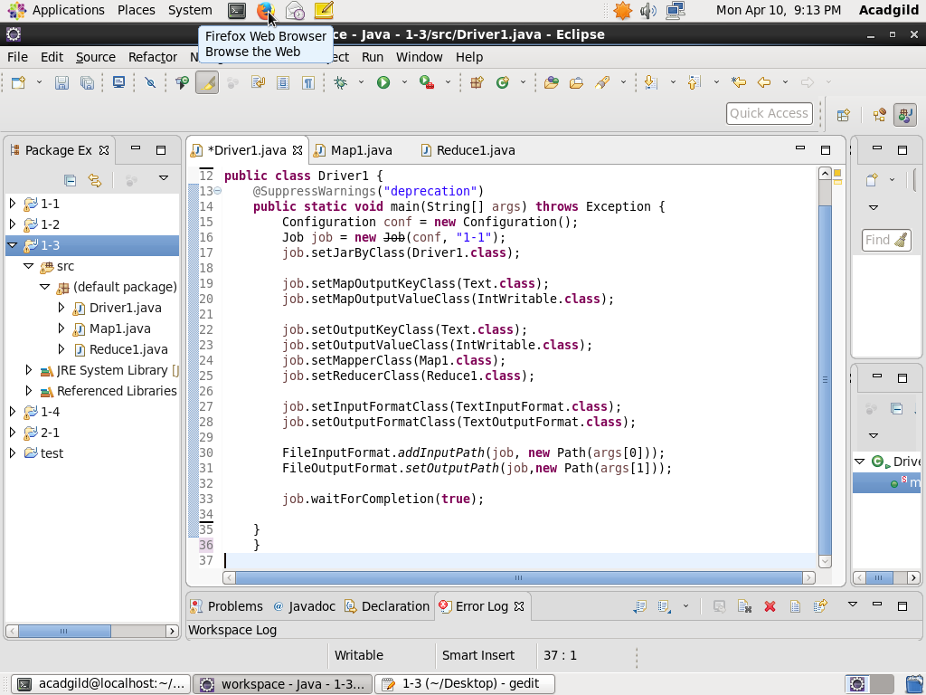

MAPPER CLASS

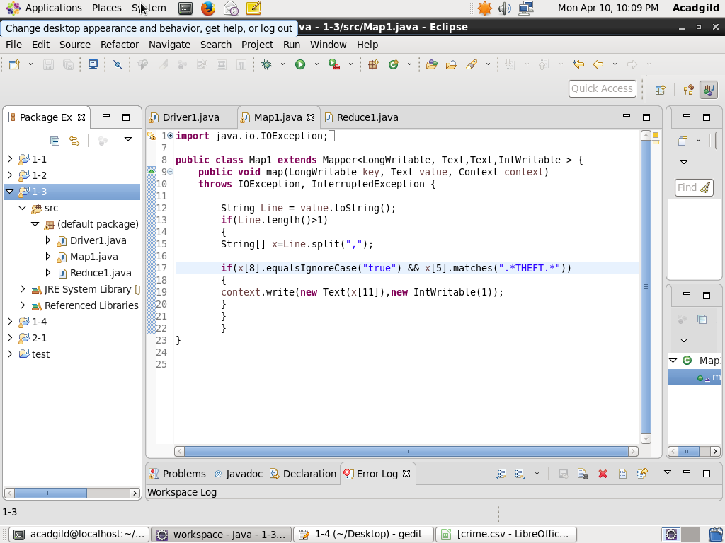

REDUCER CLASS

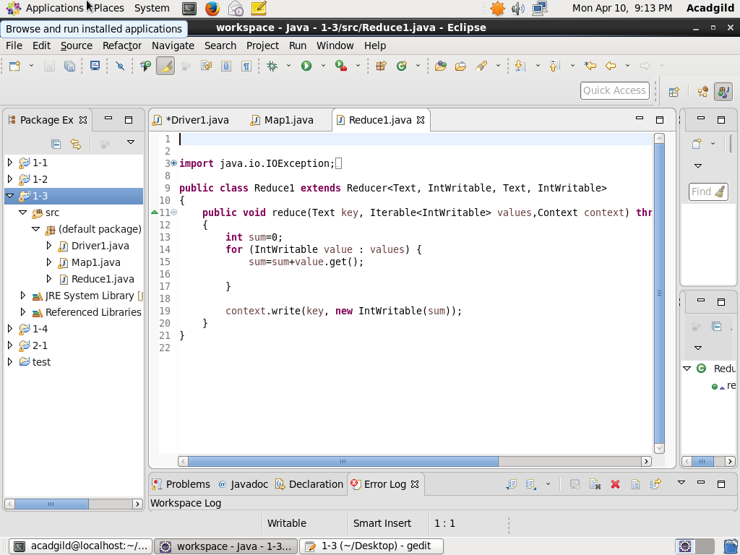

**EXECUTION COMMAND:**

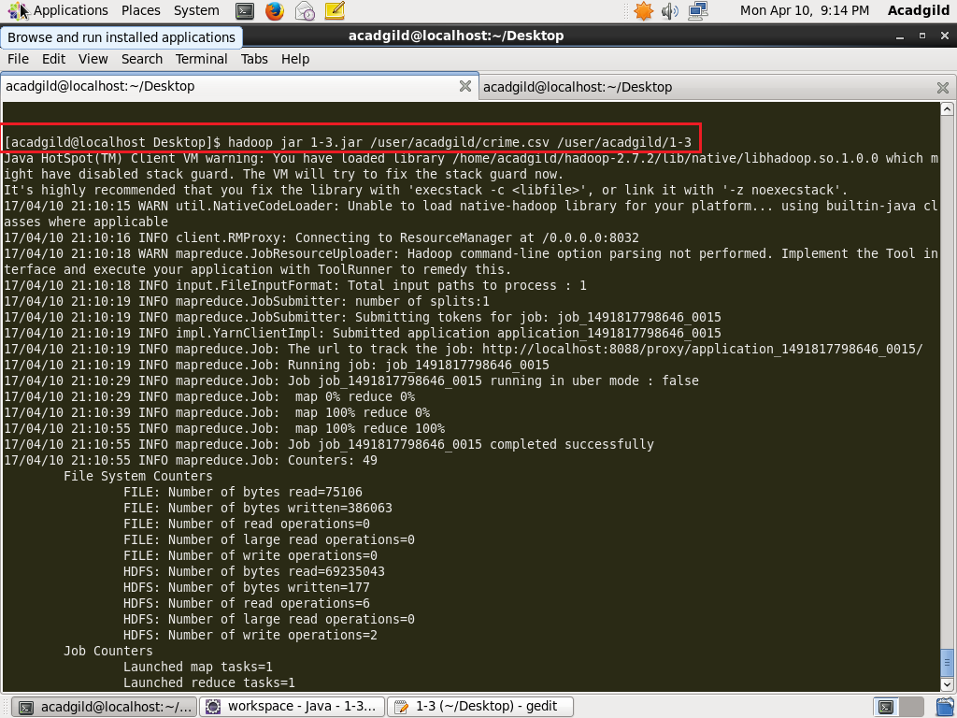

**OUTPUT:**

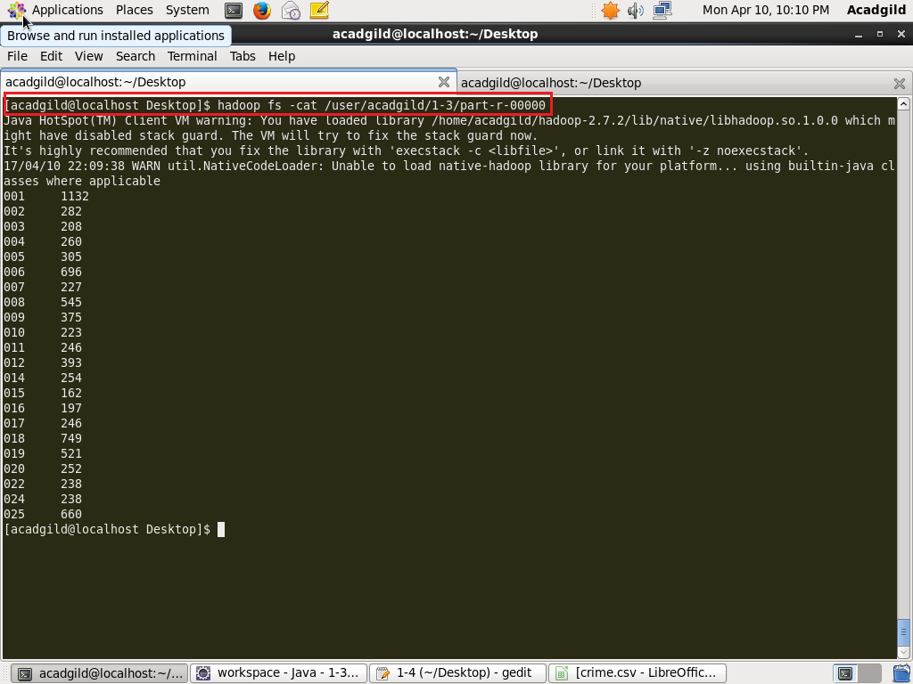

**2. PIG:**

**PROGRAM:**

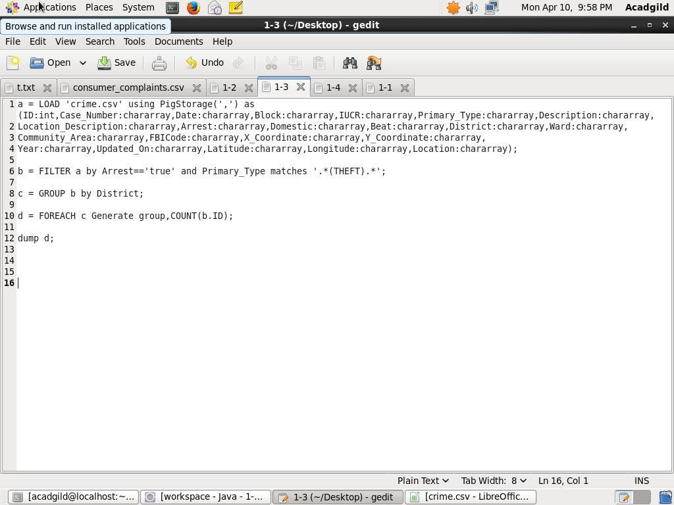

**EXECUTION COMMAND:**

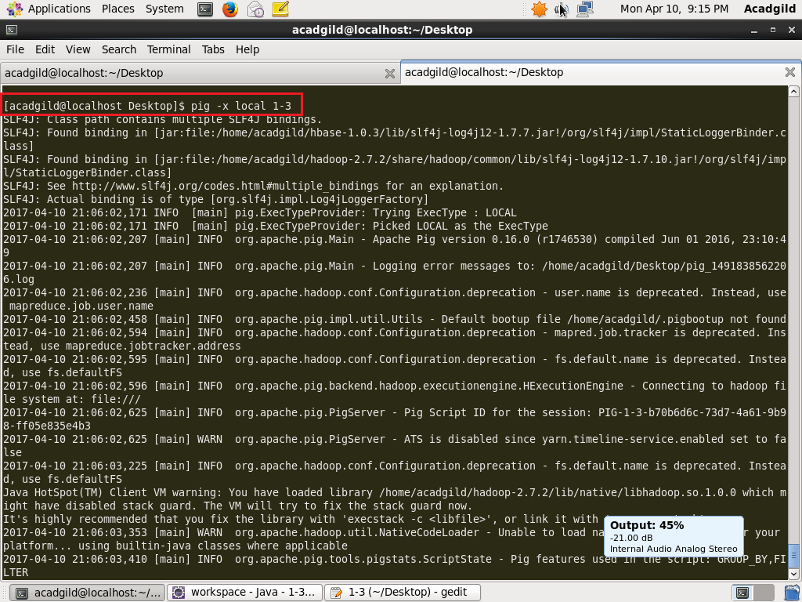

**OUTPUT:**

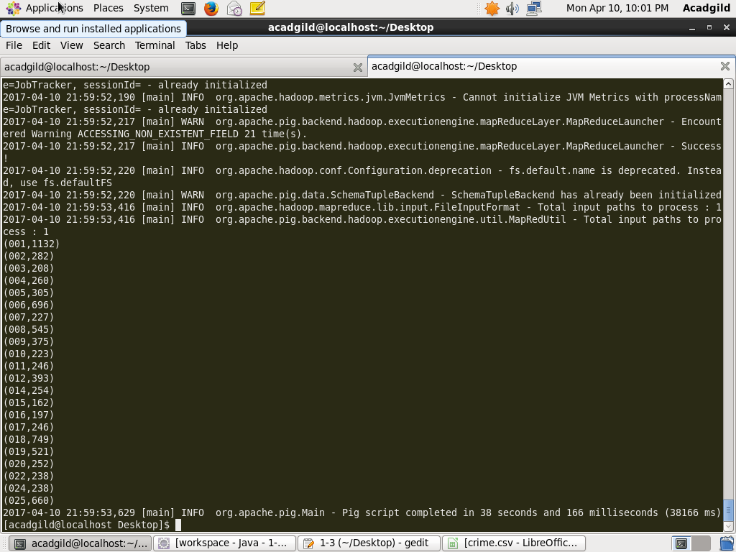

**Q4-Write a mapreduce and pig program to calculate the number of arrests done between October 2014 and October 2015.**

**SOLUTION:**

**1. MAP REDUCE:**

**PROGRAM:**

DRIVER CLASS

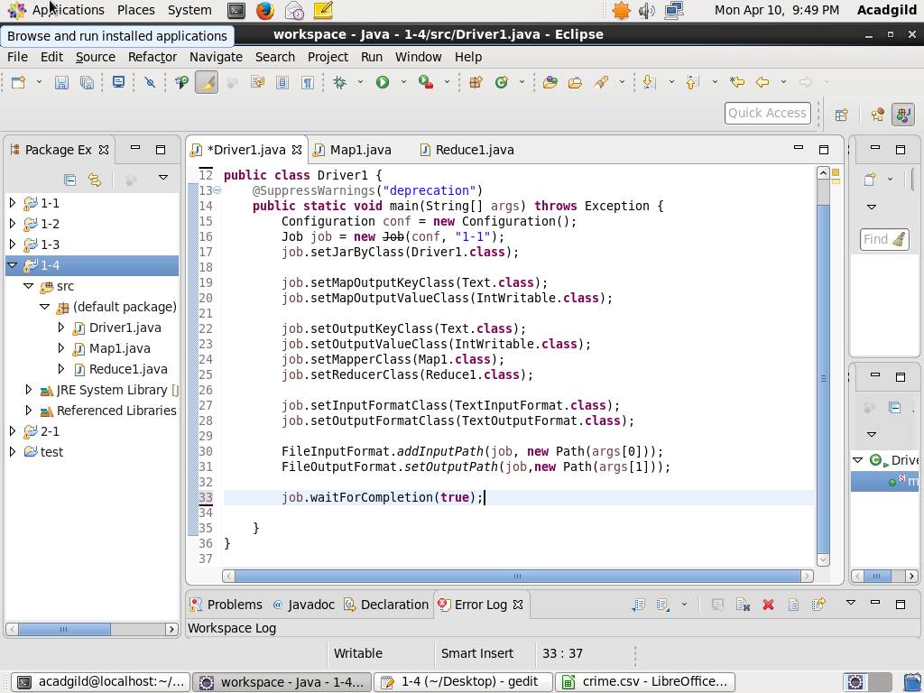

MAPPER CLASS

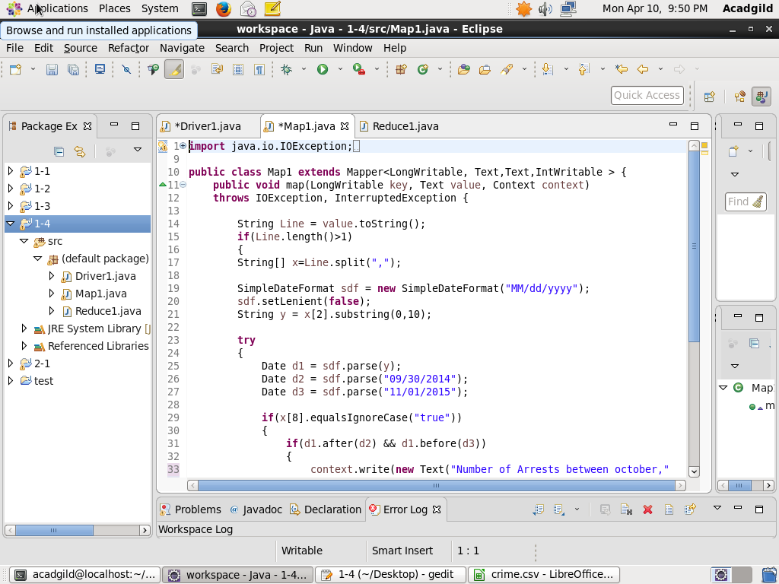

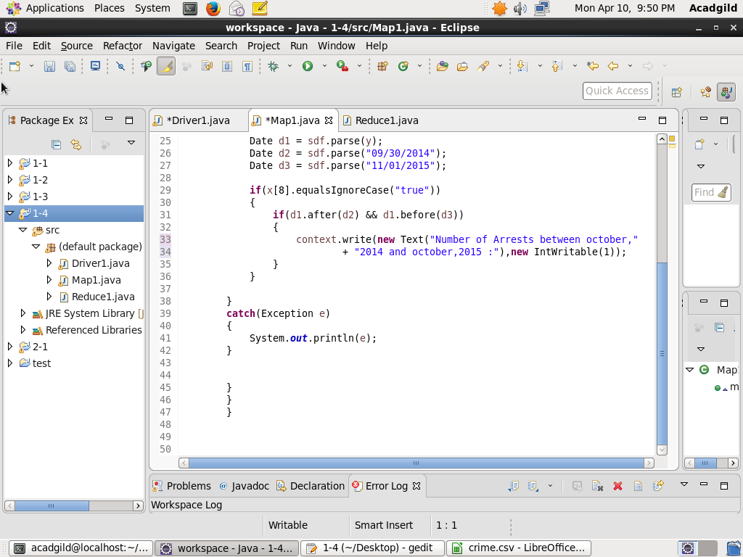

REDUCER CLASS

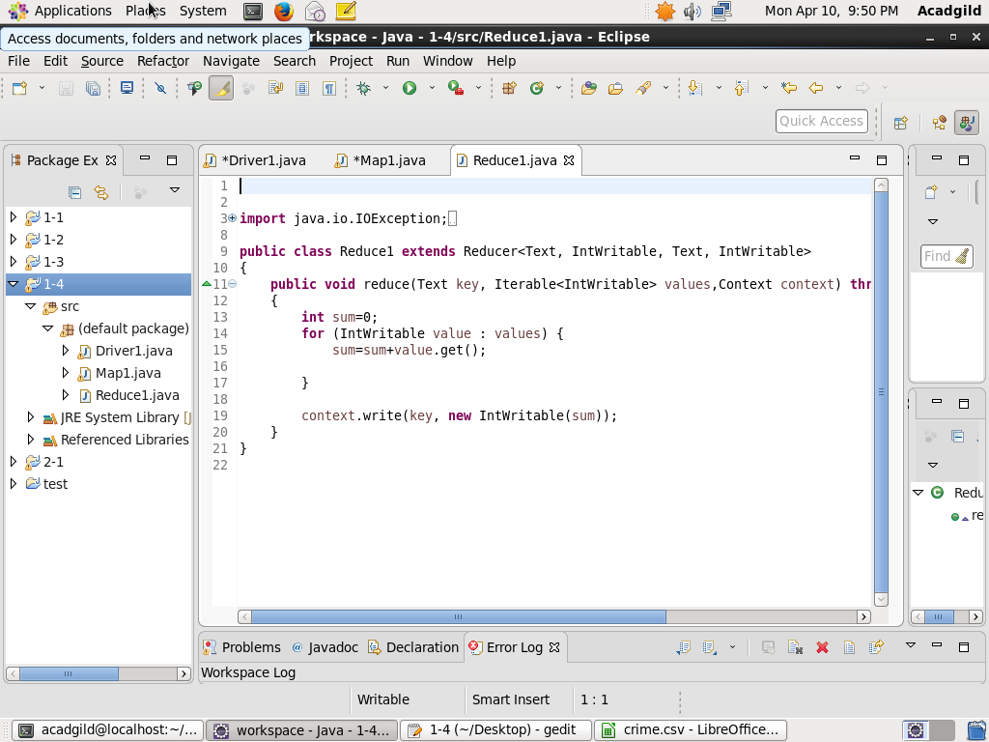

**EXECUTION COMMAND:**

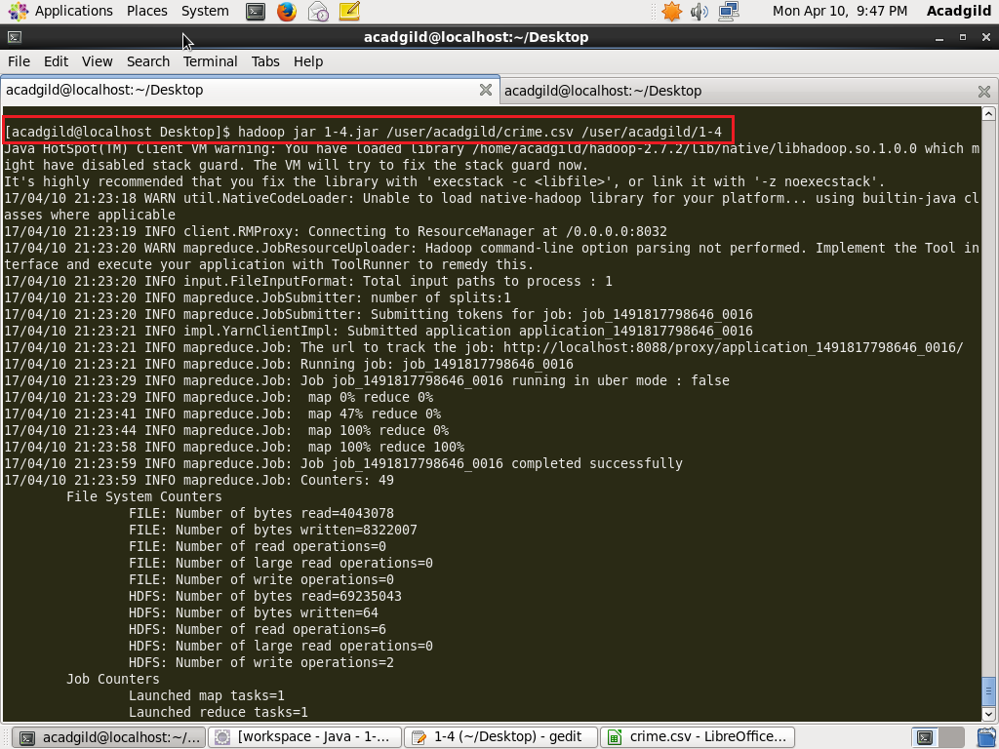

**OUTPUT:**

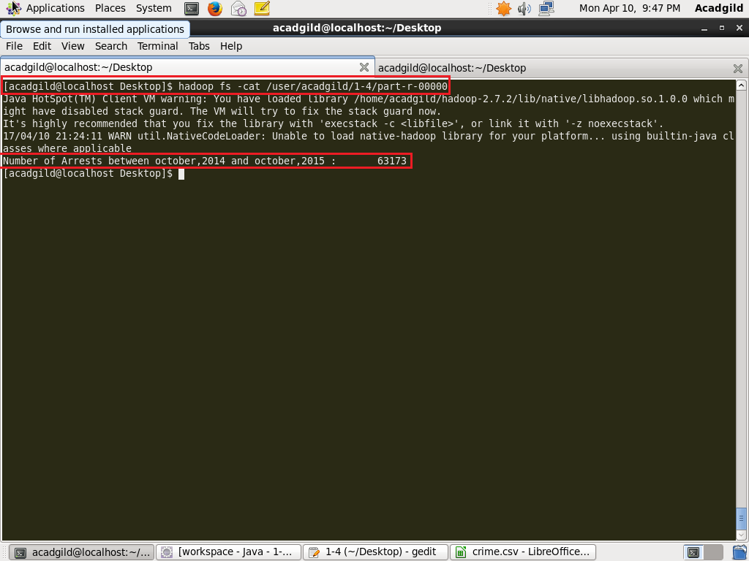

**2. PIG**

**PROGRAM:**

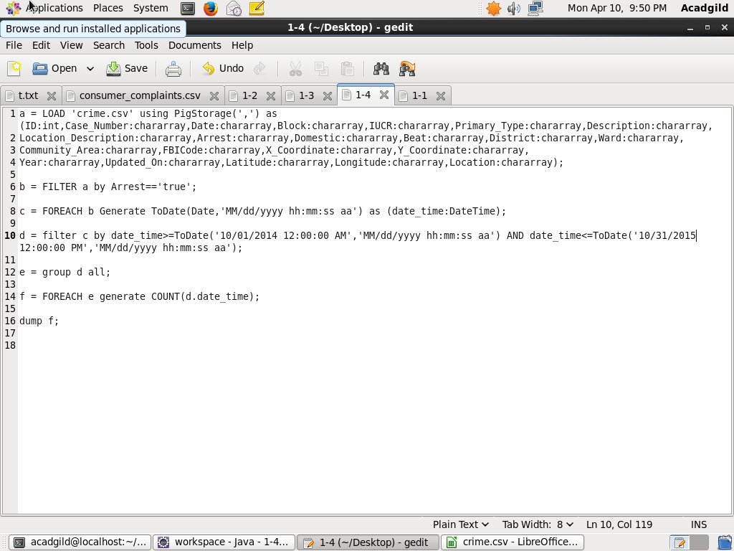

**EXECUTION COMMAND:**

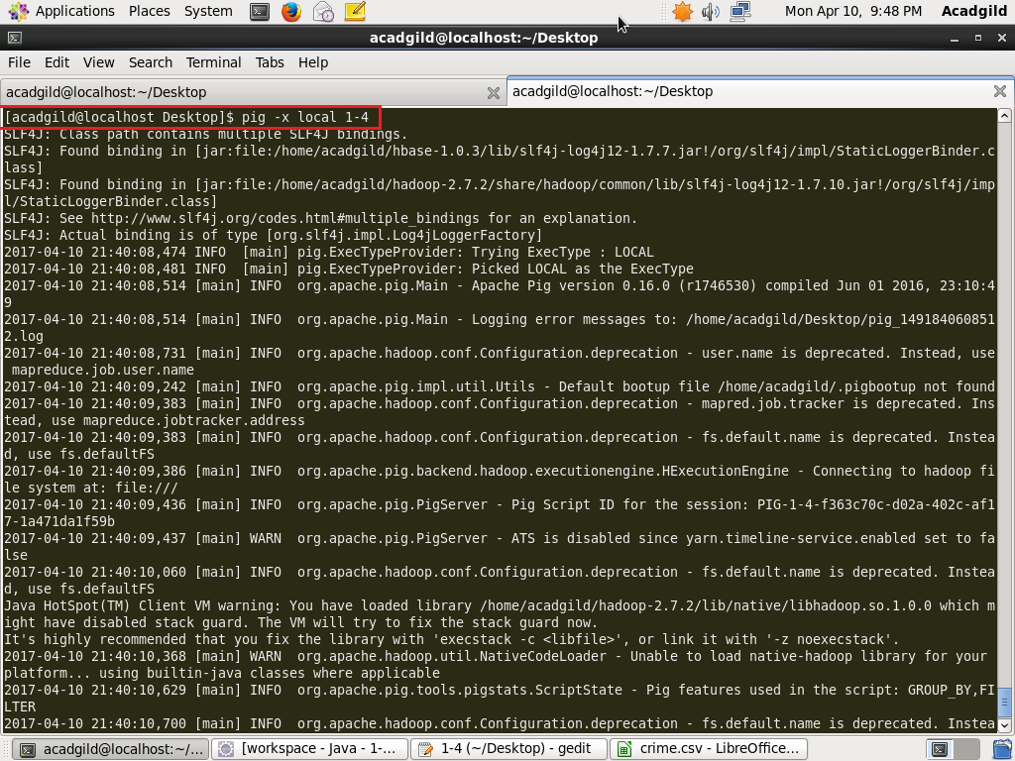

**OUTPUT:**

